Pentagonal icositetrahedron

Definition
# Source: AI Source: Provided by: [Data Path: Persons Table -> ID Column: 1, Name_En Column: Motasem Essam] -> From: [ChatGPT] on [7/25/2026]
A Pentagonal Icositetrahedron is a convex Catalan solid consisting of 24 congruent irregular pentagonal faces, 60 edges, and 38 vertices.
It is the dual polyhedron of the Snub Cube, an Archimedean solid.
It is also known as a Pentagonal Icosikaitetrahedron. In crystallography, it is associated with the term gyroid.

Simple Definition
# Source: AI Source: Provided by: [Data Path: Persons Table -> ID Column: 1, Name_En Column: Motasem Essam] -> From: [ChatGPT] on [7/25/2026]
A Pentagonal Icositetrahedron is a three-dimensional solid made up of 24 identical pentagon-shaped faces. It has a twisted, asymmetrical appearance and comes in two mirror-image forms: left-handed and right-handed.
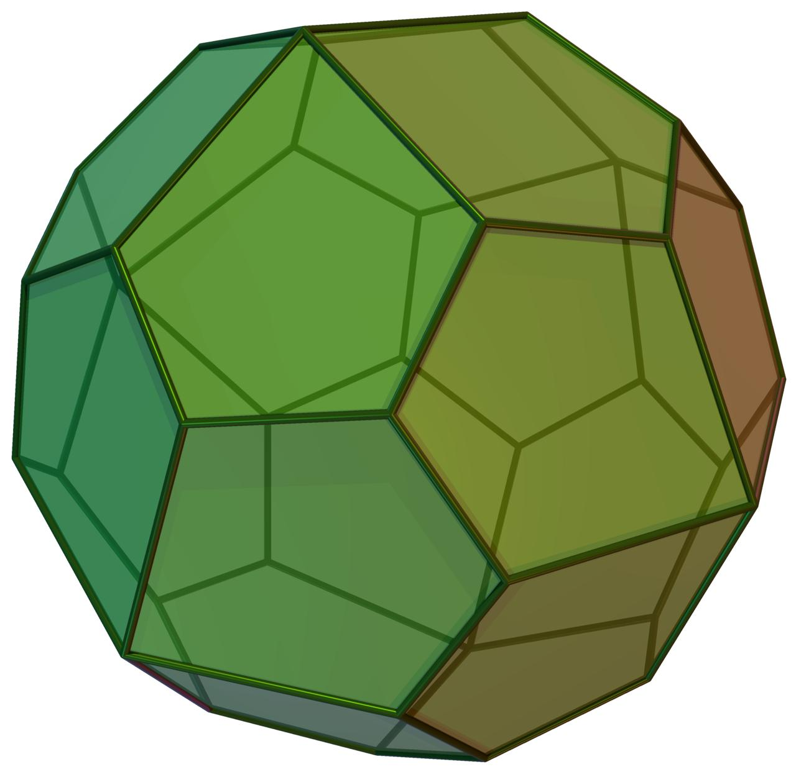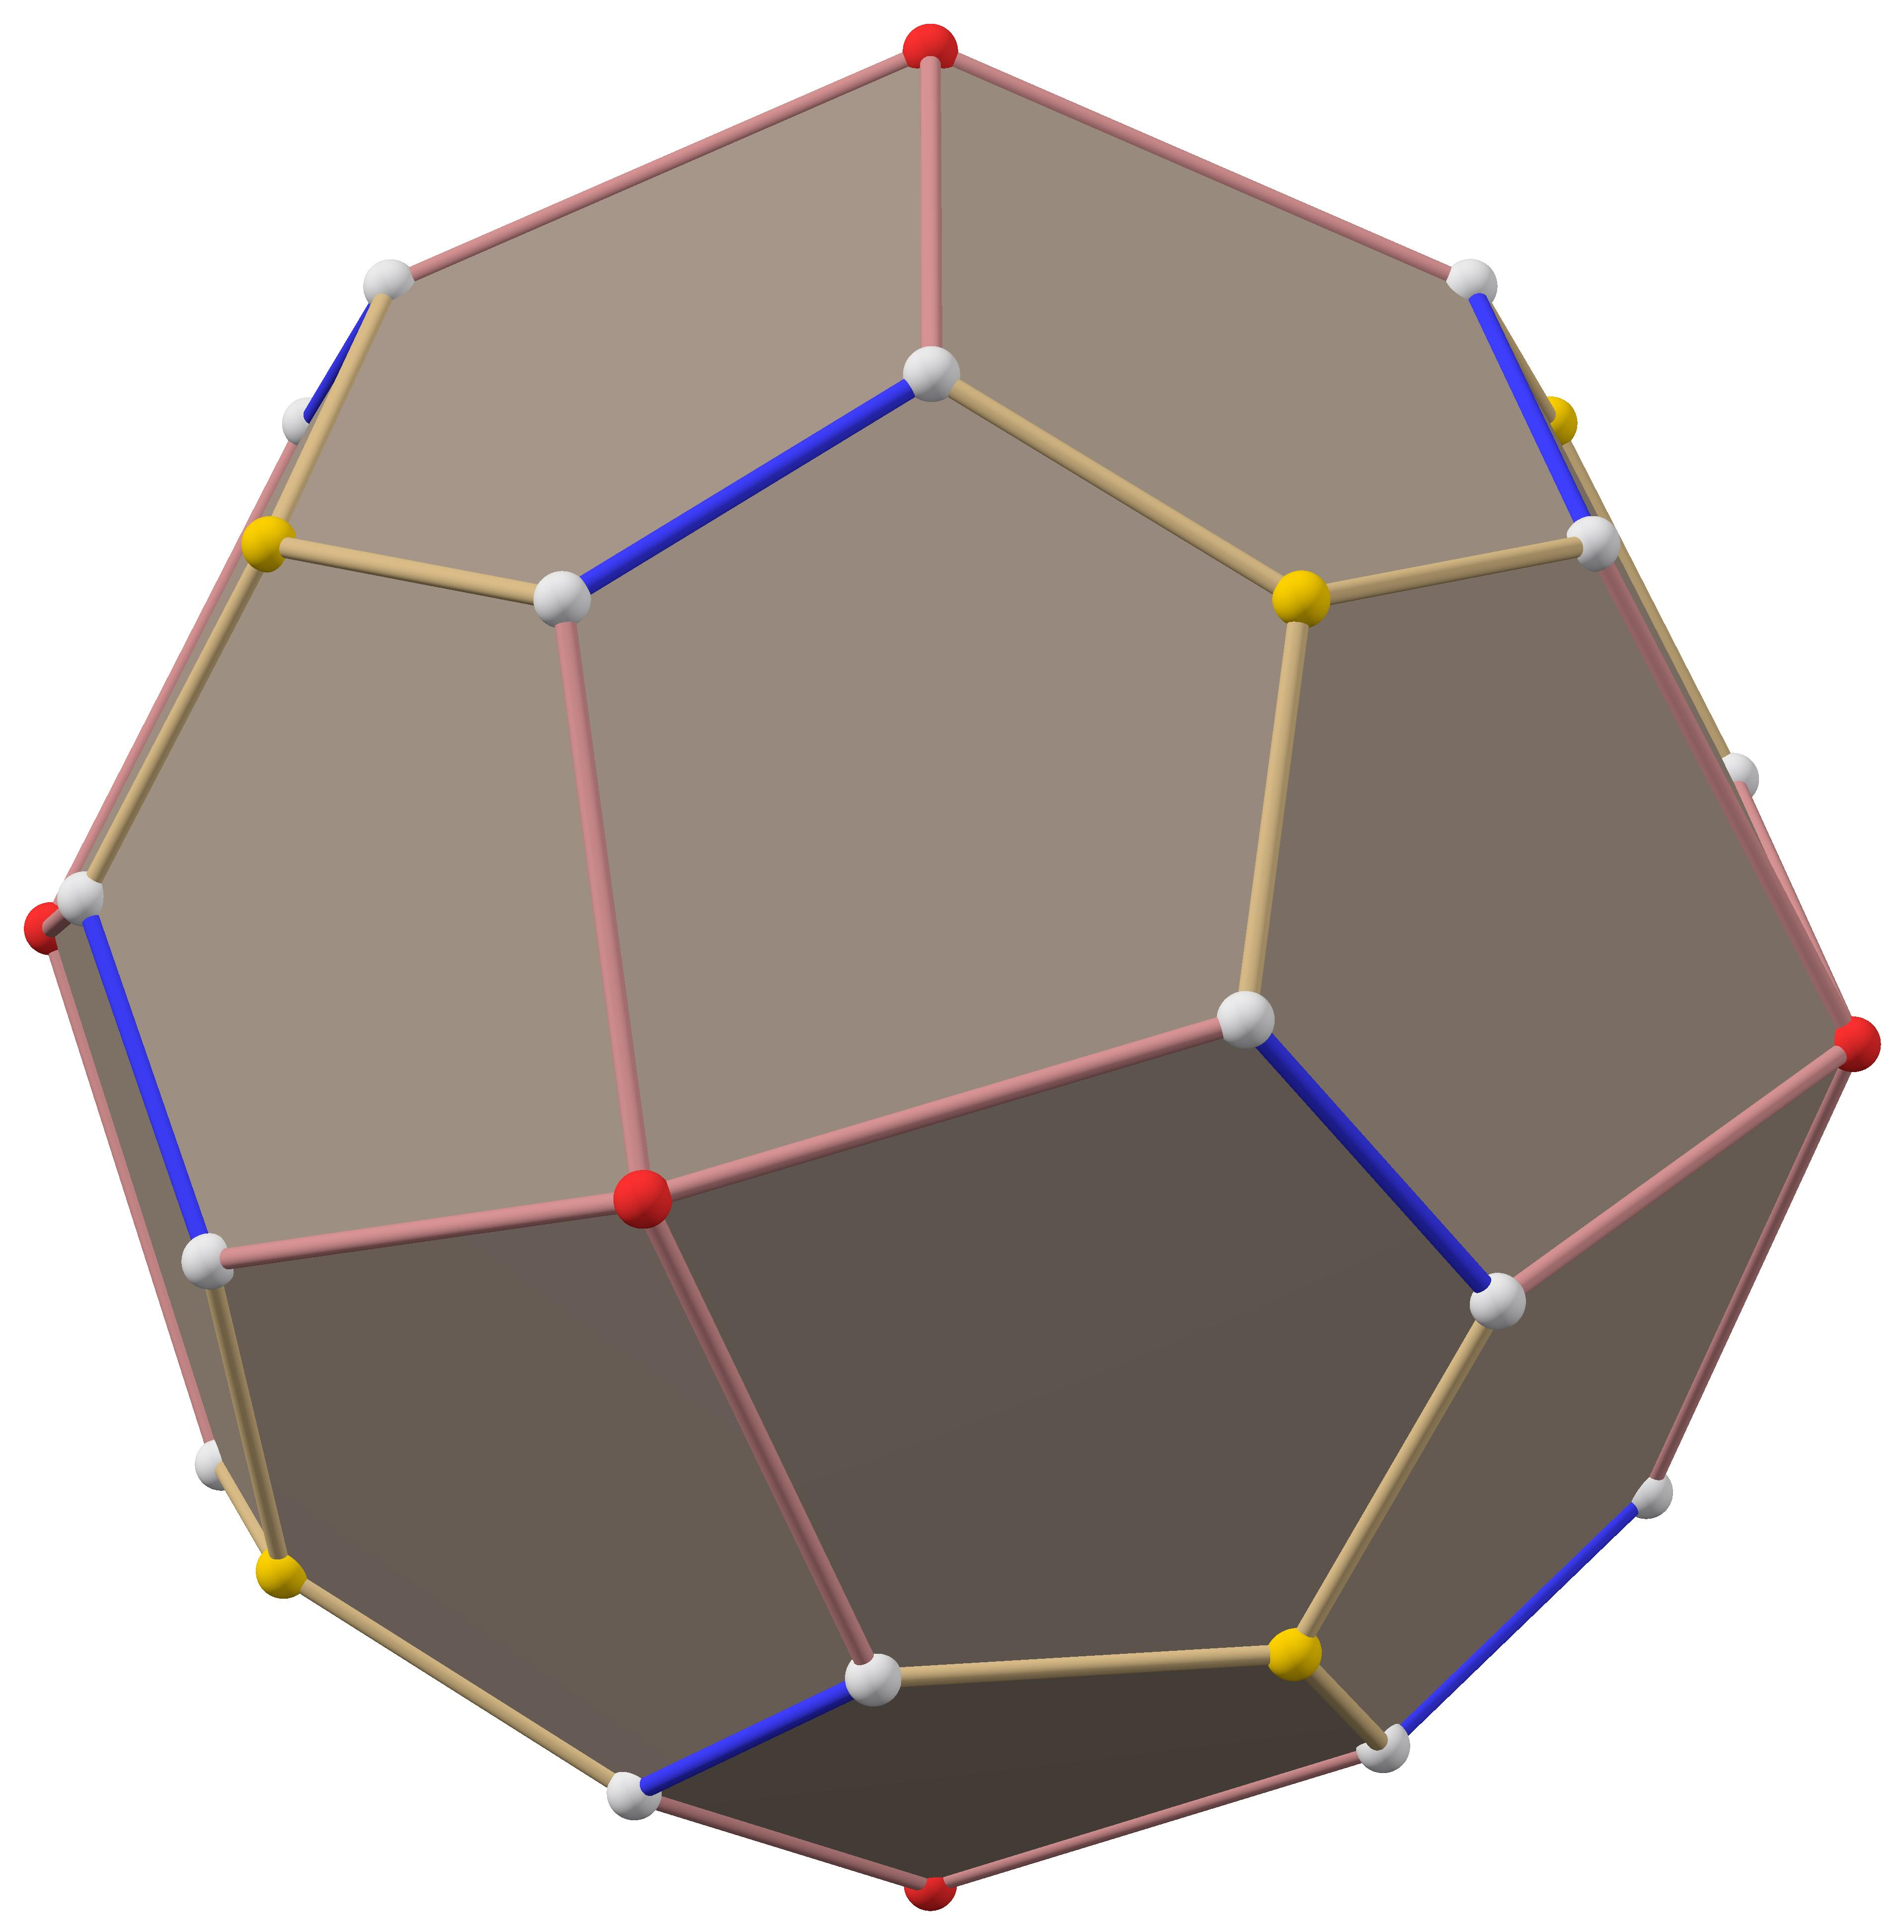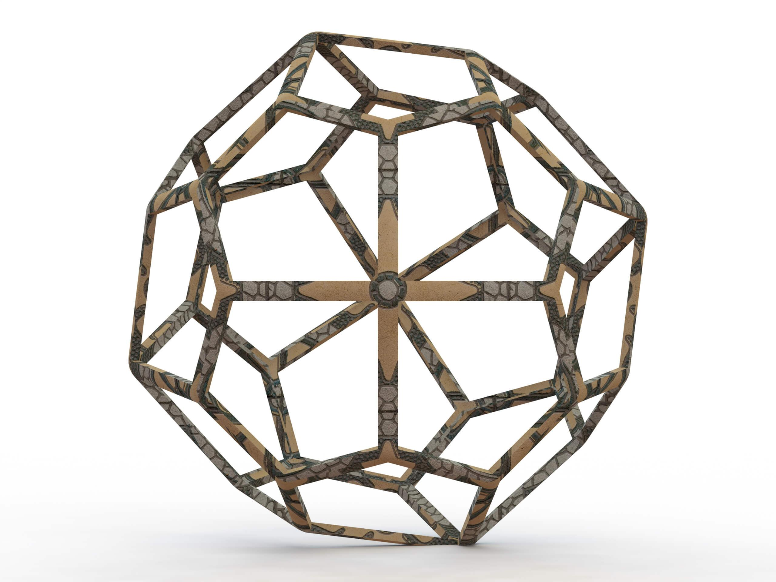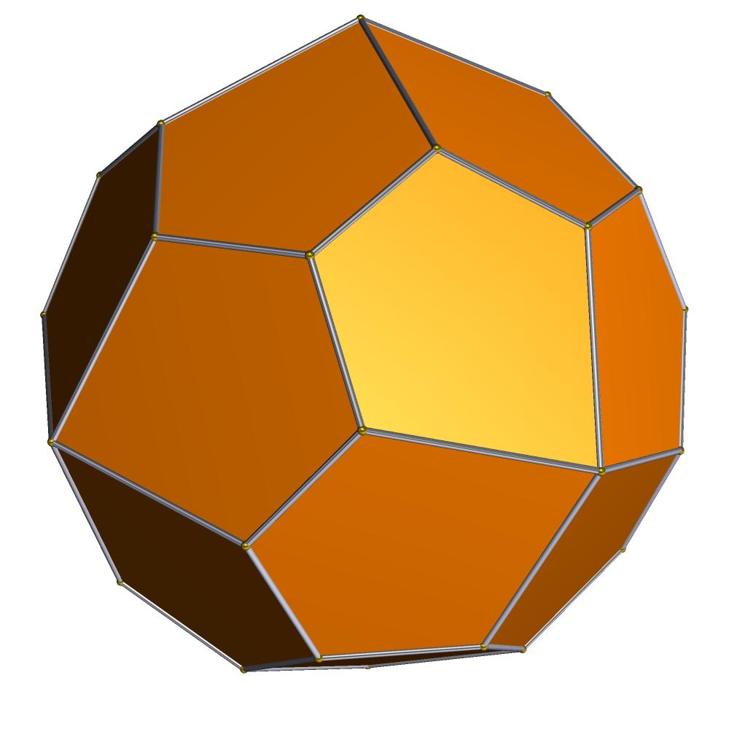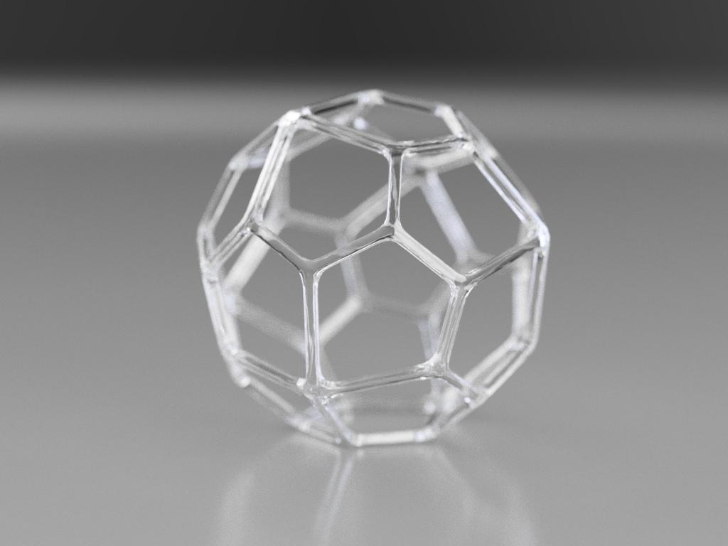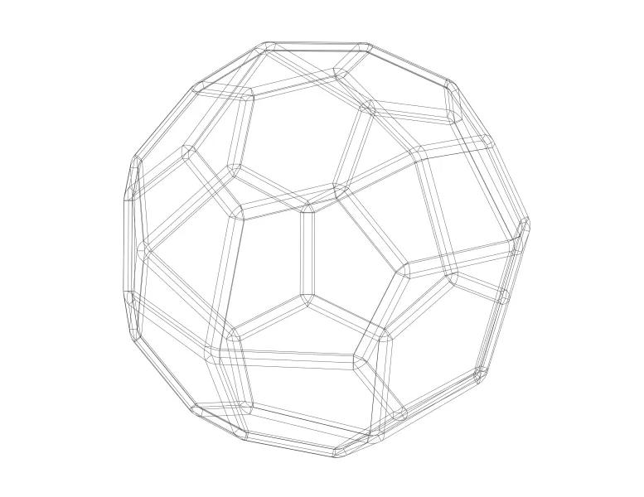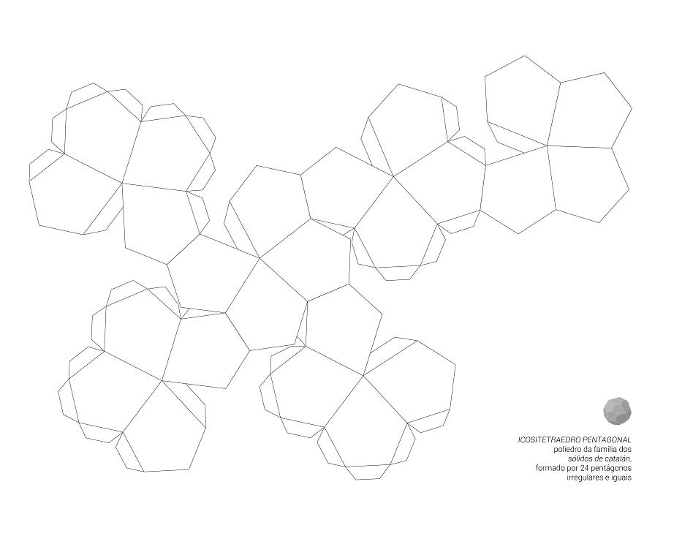

Geometric Structure
# Source: AI Source: Provided by: [Data Path: Persons Table -> ID Column: 1, Name_En Column: Motasem Essam] -> From: [ChatGPT] on [7/25/2026]
- It is a convex polyhedron.
- It has 24 congruent irregular pentagonal faces.
- It has 60 edges.
- It has 38 vertices.
- It has two different edge lengths.
- Its vertices have two different configurations.
- It has chiral octahedral symmetry.
The solid is constructed as the dual of a Snub Cube.

Face Structure
# Source: AI Source: Provided by: [Data Path: Persons Table -> ID Column: 1, Name_En Column: Motasem Essam] -> From: [ChatGPT] on [7/25/2026]
The Pentagonal Icositetrahedron has 24 congruent irregular pentagonal faces.
Each face is a pentagon with five sides, but its sides and angles are not all equal.
Important characteristics:
- All 24 pentagons are congruent.
- Each pentagon has five sides.
- The faces are irregular rather than regular pentagons.
- Each face has a mirror-symmetric shape.

Edge Structure
# Source: AI Source: Provided by: [Data Path: Persons Table -> ID Column: 1, Name_En Column: Motasem Essam] -> From: [ChatGPT] on [7/25/2026]
The solid has 60 edges, divided into two groups:
- 36 shorter edges.
- 24 longer edges.
For the canonical model whose dual Snub Cube has unit edge length:
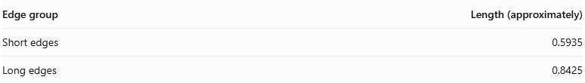
Edge group | Length (approximately)
Short edges | 0.5935
Long edges | 0.8425
The ratio is approximately:
$$\frac{\text{Short edge}}{\text{Long edge}}≈0.7047$$

Vertex Structure
# Source: AI Source: Provided by: [Data Path: Persons Table -> ID Column: 1, Name_En Column: Motasem Essam] -> From: [ChatGPT] on [7/25/2026]
The Pentagonal Icositetrahedron has 38 vertices, divided into two groups:
- 32 vertices of degree 3: Three pentagonal faces meet at each vertex.
- 6 vertices of degree 4: Four pentagonal faces meet at each vertex.
Its vertex configuration is commonly represented as:
$$V_{3}^{32}+V_{4}^{6}$$

Mathematical Properties
# Source: AI Source: Provided by: [Data Path: Persons Table -> ID Column: 1, Name_En Column: Motasem Essam] -> From: [ChatGPT] on [7/25/2026]
24
Faces
60
Edges
38
Vertices
136.31°
Dihedral angle (approx.)
Euler's formula
$$V-E+F=2$$
$$38-60+24=2$$
The Pentagonal Icositetrahedron satisfies Euler's polyhedron formula.

Face configuration
# Source: AI Source: Provided by: [Data Path: Persons Table -> ID Column: 1, Name_En Column: Motasem Essam] -> From: [ChatGPT] on [7/25/2026]
The face configuration at each vertex is:
$$3.3.3.3.4$$
This means that the corresponding vertex of the dual Snub Cube has four triangular faces and one square face meeting around it.

Symmetry
# Source: AI Source: Provided by: [Data Path: Persons Table -> ID Column: 1, Name_En Column: Motasem Essam] -> From: [ChatGPT] on [7/25/2026]
The Pentagonal Icositetrahedron has chiral octahedral symmetry, represented by the group:
$$O$$
Its symmetry includes:
- Three-fold rotational axes.
- Four-fold rotational axes.
- Two-fold rotational axes.
- No reflection planes.
- No inversion symmetry.

Chirality
# Source: AI Source: Provided by: [Data Path: Persons Table -> ID Column: 1, Name_En Column: Motasem Essam] -> From: [ChatGPT] on [7/25/2026]
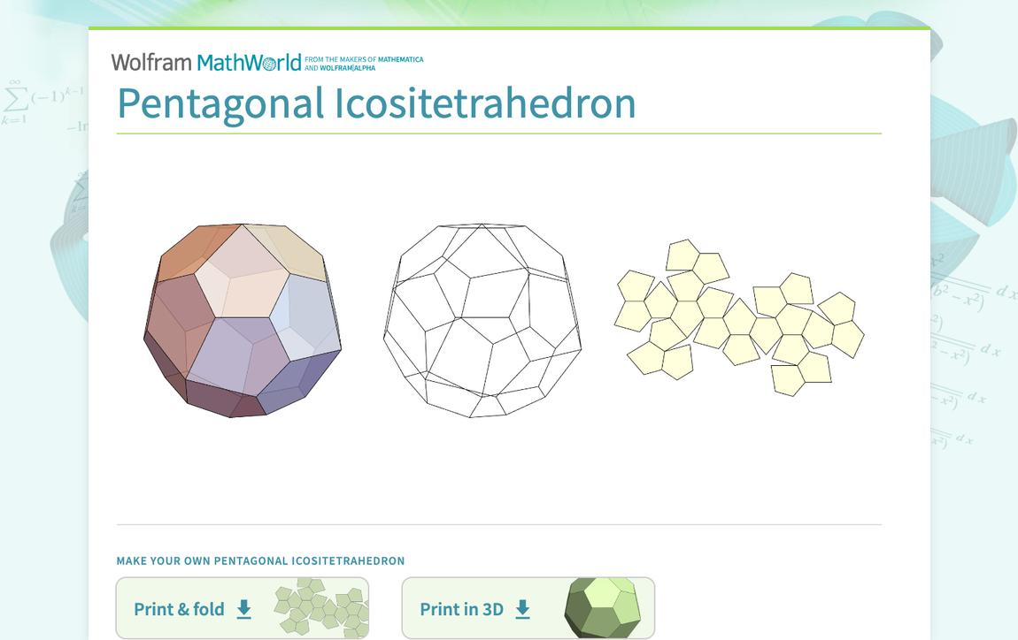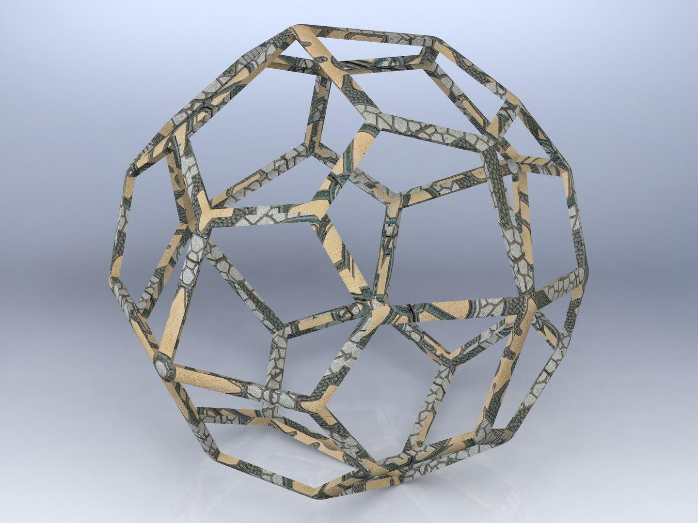
The Pentagonal Icositetrahedron is a chiral solid, meaning that it exists in two forms:
- Dextro form: Right-handed version.
- Laevo form: Left-handed version.
These two forms are mirror images of one another, but they cannot be superimposed by rotation alone.

Surface Area and Volume
# Source: AI Source: Provided by: [Data Path: Persons Table -> ID Column: 1, Name_En Column: Motasem Essam] -> From: [ChatGPT] on [7/25/2026]
The surface area and volume depend on the scale of the solid.

Surface area
# Source: AI Source: Provided by: [Data Path: Persons Table -> ID Column: 1, Name_En Column: Motasem Essam] -> From: [ChatGPT] on [7/25/2026]
Since all 24 faces are congruent:
$$SA=24A_{f}$$
For an irregular pentagonal face, its area can be calculated by dividing it into three triangles and adding their areas.

Volume
# Source: AI Source: Provided by: [Data Path: Persons Table -> ID Column: 1, Name_En Column: Motasem Essam] -> From: [ChatGPT] on [7/25/2026]
For the canonical model whose dual Snub Cube has unit edge length:
$$\boxed{V≈7.447395}$$
The volume scales with the cube of the linear scale factor.

Relationship to Other Solids

Dual: Snub Cube
# Source: AI Source: Provided by: [Data Path: Persons Table -> ID Column: 1, Name_En Column: Motasem Essam] -> From: [ChatGPT] on [7/25/2026]
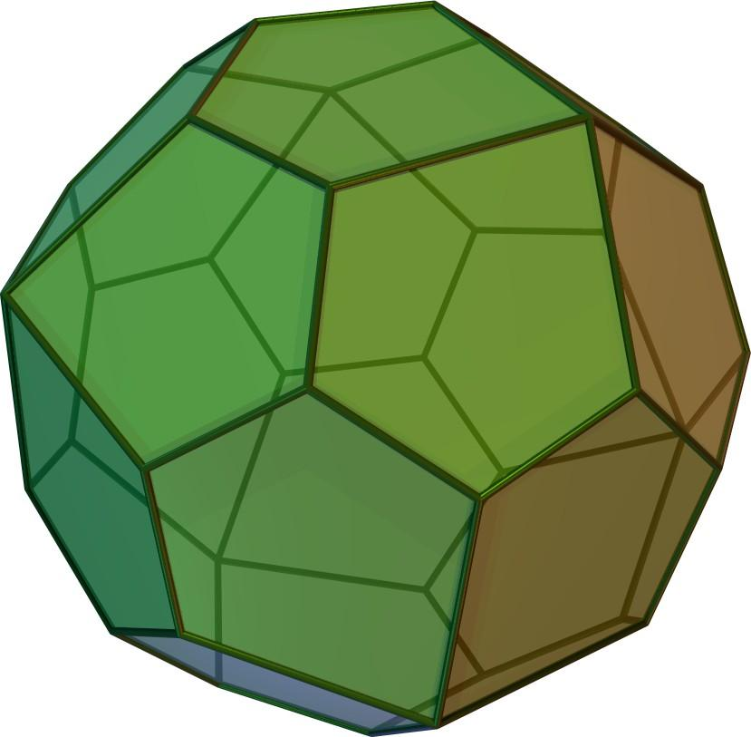
Pentagonal Icositetrahedron
Catalan solid
<icon name="arrow-left-right" size="xl"/>
Duality
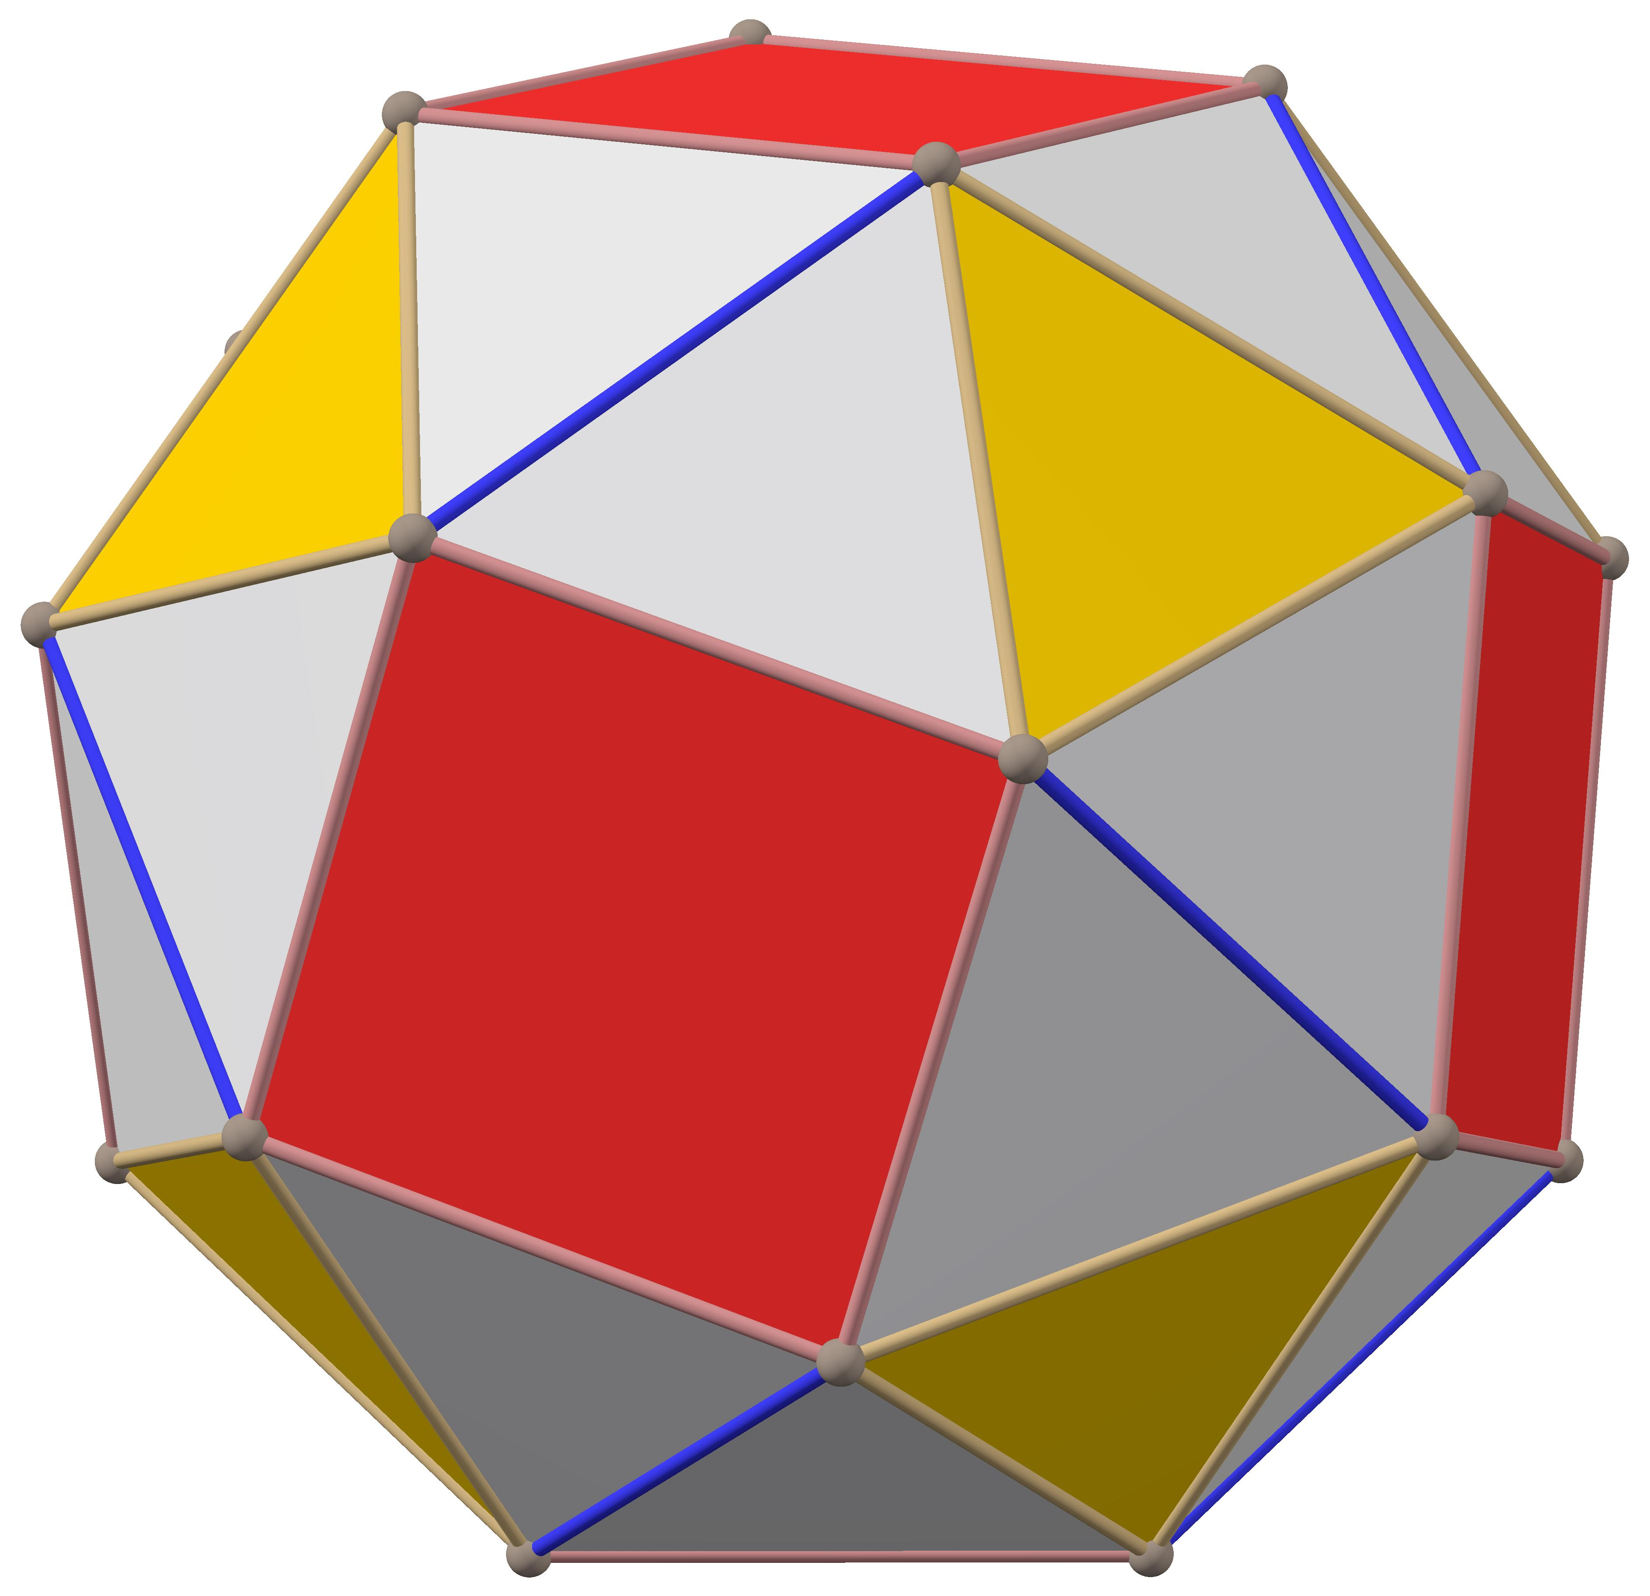
Snub Cube
Archimedean solid
The Pentagonal Icositetrahedron is the dual of the Snub Cube.
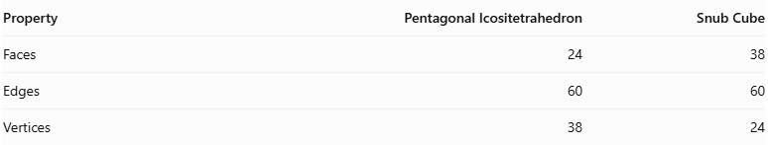
Property | Pentagonal Icositetrahedron | Snub Cube
Faces | 24 | 38
Edges | 60 | 60
Vertices | 38 | 24
In polyhedral duality:
- Each face of the Pentagonal Icositetrahedron corresponds to a vertex of the Snub Cube.
- Each vertex of the Pentagonal Icositetrahedron corresponds to a face of the Snub Cube.
- Their edges correspond to each other.

Constructing a Pentagonal Icositetrahedron

Geometric Instruments Used
# Source: AI Source: Provided by: [Data Path: Persons Table -> ID Column: 1, Name_En Column: Motasem Essam] -> From: [ChatGPT] on [7/25/2026]
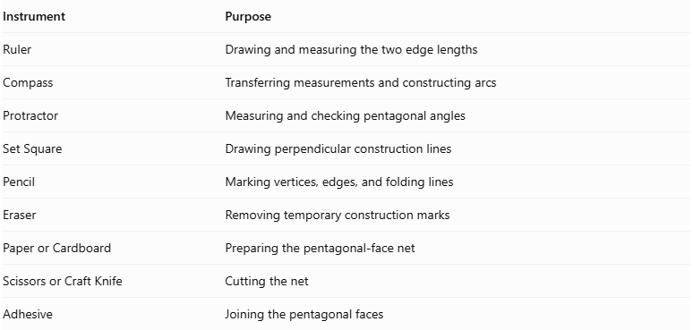
Instrument | Purpose
Ruler | Drawing and measuring the two edge lengths
Compass | Transferring measurements and constructing arcs
Protractor | Measuring and checking pentagonal angles
Set Square | Drawing perpendicular construction lines
Pencil | Marking vertices, edges, and folding lines
Eraser | Removing temporary construction marks
Paper or Cardboard | Preparing the pentagonal-face net
Scissors or Craft Knife | Cutting the net
Adhesive | Joining the pentagonal faces

Instrument-Based Construction Procedures

Method 1: Construction Using a Pentagonal Net
# Source: AI Source: Provided by: [Data Path: Persons Table -> ID Column: 1, Name_En Column: Motasem Essam] -> From: [ChatGPT] on [7/25/2026]
Step 1: Determine the Two Edge Lengths
- Select a scale for the model.
- Establish a short edge length $s$ and a long edge length $l$.
- Use the ruler and compass to transfer both measurements accurately.
For the standard Pentagonal Icositetrahedron, the ratio is:
$$\frac{s}{l}=\frac{2}{τ+1}$$
where $τ$ is the Tribonacci constant:
$$τ^{3}-τ^{2}-τ-1=0$$
$$τ≈1.839286755$$
Therefore:
$$\frac{s}{l}≈0.704$$
Step 2: Construct the First Irregular Pentagon
- Draw a pentagon with five vertices.
- Arrange its edges in the following order around the boundary:
- Two adjacent long edges meeting at the apex.
- Three short edges forming the remaining boundary.
- Use a ruler and compass to transfer the required edge lengths.
- Use a protractor to check the interior angles.
Step 3: Verify the Pentagon's Geometry
The standard pentagonal face has:
- Three short edges.
- Two long edges.
- One apex angle of approximately ${80.75}^{°}$.
- Four other interior angles of approximately ${114.81}^{°}$.
The sum of its interior angles is:
$${80.75}^{°}+4({114.81}^{°})≈{540}^{°}$$
Step 4: Construct the Remaining Faces
- Construct 23 additional pentagons.
- Maintain the same edge lengths and interior angles.
- Preserve the same orientation of the pentagonal face.
- Ensure that all 24 faces are congruent.
Step 5: Arrange the Pentagonal Faces
- Arrange all 24 pentagons according to the correct net.
- Follow the face adjacency of the Pentagonal Icositetrahedron.
- Ensure that the net produces the correct three-valent and four-valent vertices.
- Add joining tabs along selected outer edges.
Step 6: Cut Out the Net
- Cut around the external boundary.
- Preserve all joining tabs.
- Avoid cutting along the internal folding lines.
Step 7: Fold the Pentagonal Faces
- Fold along the shared edges.
- Raise the pentagonal faces gradually.
- Match the corresponding short and long edges.
- Maintain the selected mirror-image orientation throughout assembly.
Step 8: Join the Faces
- Apply adhesive to the joining tabs.
- Connect the corresponding edges.
- Allow the model to hold its three-dimensional shape.
Step 9: Complete the Solid
Verify that the finished model has:
- 24 congruent pentagonal faces.
- 60 edges.
- 38 vertices.
- 36 short edges.
- 24 long edges.
- 32 three-valent vertices.
- 6 four-valent vertices.
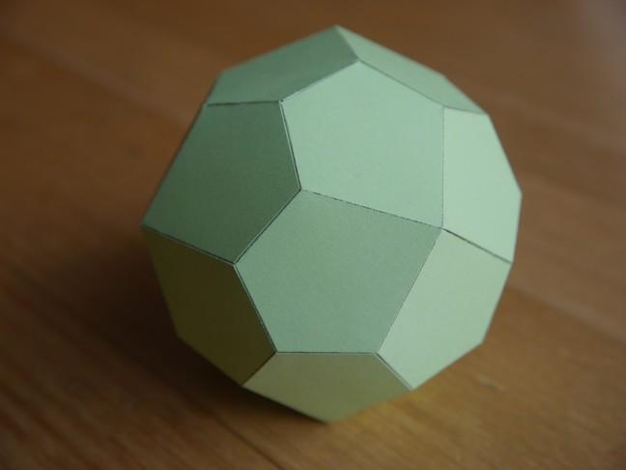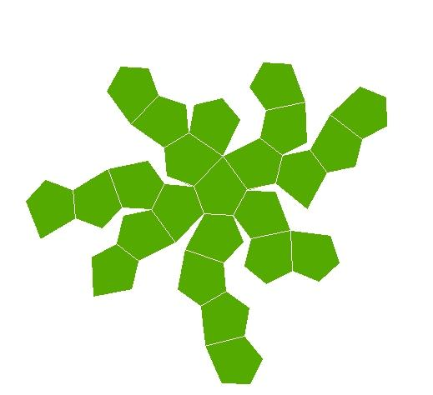

Method 2: Construction Using the Dual of a Snub Cube
# Source: AI Source: Provided by: [Data Path: Persons Table -> ID Column: 1, Name_En Column: Motasem Essam] -> From: [ChatGPT] on [7/25/2026]
This method uses the dual relationship between the Snub Cube and the Pentagonal Icositetrahedron.
Step 1: Construct the Snub Cube
- Prepare a reference model of a Snub Cube.
- Identify its 6 square faces and 32 equilateral triangular faces.
- Verify its 60 vertices and 60 edges.
Step 2: Identify the Face Centers
- Mark the center of each of the 38 faces.
- Identify the orientation of each face.
- Use the centers as references for constructing the dual vertices.
Step 3: Establish the Dual Vertices
- Construct one dual vertex for each original face.
- Position each dual vertex along the corresponding face-normal direction.
- Apply the appropriate dual scaling so that the resulting faces are congruent pentagons.
Step 4: Identify the Original Vertices
- Examine each of the 60 original Snub Cube vertices.
- Identify the faces meeting at each vertex.
- Each original vertex corresponds to one pentagonal face in the dual.
Step 5: Connect the Dual Vertices
- Connect the dual vertices associated with the faces surrounding each original vertex.
- Form a pentagonal face for each original vertex.
- Repeat for all 60 original vertices.
Step 6: Complete the Dual Structure
- Verify that all 24 pentagonal faces are formed.
- Check the 38 dual vertices and 60 edges.
- Preserve the correct short-edge and long-edge proportions.
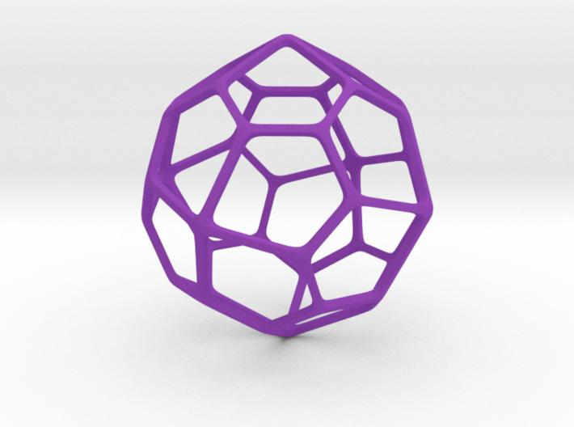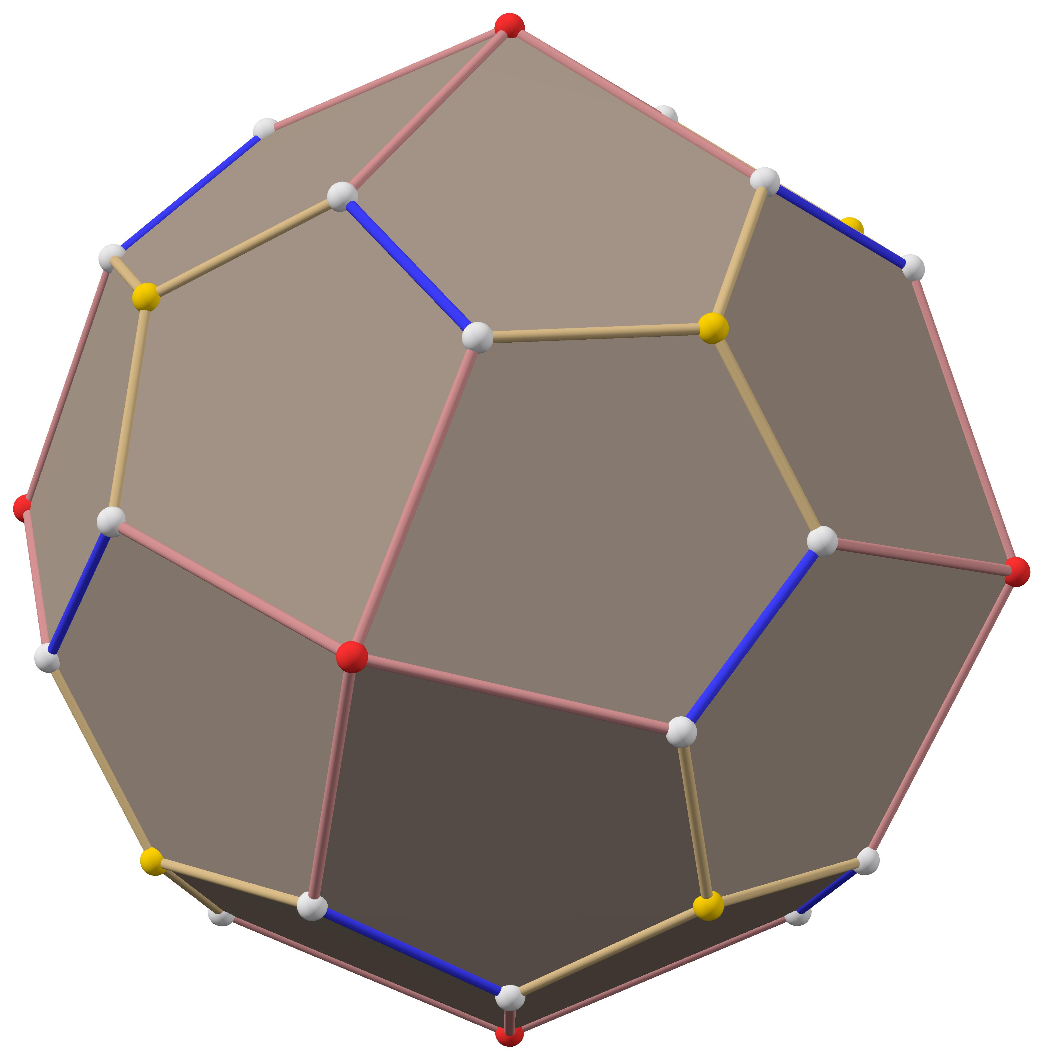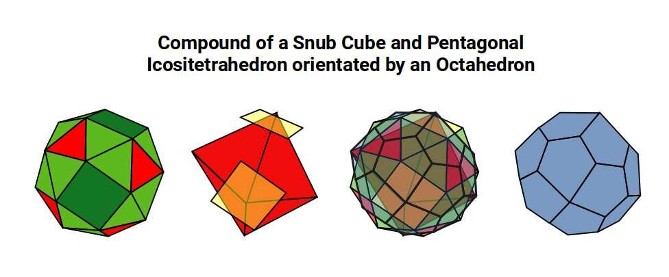
Important: Simply connecting the ordinary face centers of a Snub Cube does not necessarily produce the standard Pentagonal Icositetrahedron. The dual vertices must be positioned using the appropriate polar-dual construction.

Constructing a Pentagonal Icositetrahedron in Solid Geometry
# Source: AI Source: Provided by: [Data Path: Persons Table -> ID Column: 1, Name_En Column: Motasem Essam] -> From: [ChatGPT] on [7/25/2026]
Required instruments:
- Ruler
- Compass
- Protractor
- Pencil
- Drawing paper
- Cardboard or construction paper for a physical model
Conceptual construction steps:
- Construct a Snub Cube.
- Identify the center of each of its 38 faces.
- Mark each face center as a vertex of the dual solid.
- Connect the centers of adjacent faces.
- Form the 24 pentagonal faces.
- Ensure that the resulting pentagons are congruent.
- Complete the polyhedron, preserving the correct handedness.
- Repeat the construction with the opposite orientation to obtain its mirror-image form.

Key Points
# Source: AI Source: Provided by: [Data Path: Persons Table -> ID Column: 1, Name_En Column: Motasem Essam] -> From: [ChatGPT] on [7/25/2026]
- The Pentagonal Icositetrahedron is a Catalan solid.
- It has 24 congruent irregular pentagonal faces.
- It has 60 edges and 38 vertices.
- Its edges consist of 36 shorter edges and 24 longer edges.
- Its vertices have two configurations: degree 3 and degree 4.
- It is the dual of the Snub Cube.
- It has chiral octahedral symmetry $O$.
- It exists in two mirror-image forms: dextro and laevo.
- It is convex and face-transitive.

Conclusion
# Source: AI Source: Provided by: [Data Path: Persons Table -> ID Column: 1, Name_En Column: Motasem Essam] -> From: [ChatGPT] on [7/25/2026]
The Pentagonal Icositetrahedron is a distinctive member of the Catalan solids family. Its 24 congruent irregular pentagonal faces, two edge lengths, and two vertex configurations give it a unique geometric structure. Its chirality and dual relationship with the Snub Cube make it an especially interesting example of symmetry and polyhedral duality.

